BAND GAP ENERGY CHARACTERISTICS IN MATERIALS:
- Band gap energy is one of the most fundamental parameters in determining the electronic and optoelectronic properties of a material.
- The band gap value is a measure of the energy jump that electrons must make in order to actively conduct electricity.
- The greater the band gap value, the greater the energy required by electrons to conduct electricity.
- The difference in band gap values in various materials affects the ability of the material to conduct electricity or interact with light.
- Therefore, understanding the characteristics of band gap energy is very important in the development of various devices such as semiconductors, photovoltaics, optical sensors, and light-emitting diodes (LEDs).
- Band gap is the energy difference between the highest occupied electron energy level (in the valence band) and the lowest empty electron energy level (in the conduction band).
- The magnitude of the band gap value is the main determinant of whether a material behaves as a conductor, semiconductor, or insulator.

Material Classification Based on Band Gap Energy
In general, materials are classified based on the size of their band gap energy as follows:
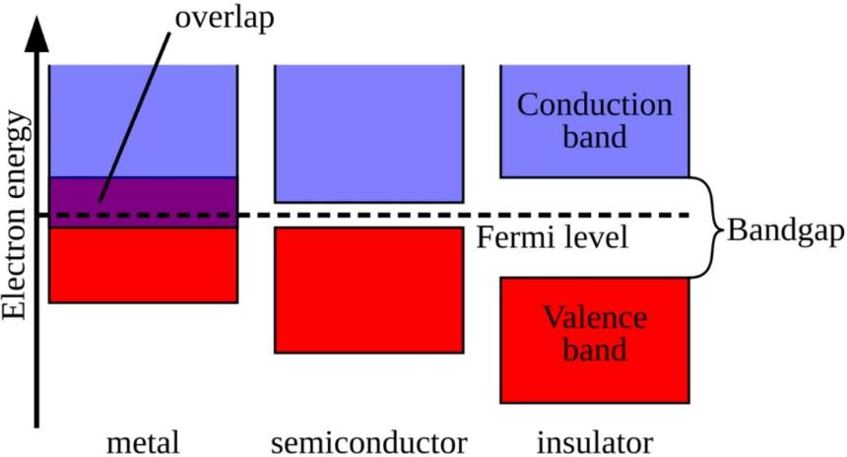

Figure 1.1: Semiconductor band gap

Conductor
It does not have a significant band gap; the valence and conduction energy bands meet. Electrons can move freely without any additional external energy. Therefore, conductors such as copper (Cu) and aluminum (Al) are very efficient in conducting electricity.
Insulator
Having a large band gap (>5 eV). Electrons are tightly bound in the valence band and require large energy to move to the conduction band, making them almost incapable of conducting electricity. Examples of insulators are glass, ceramics, and mica.

Semiconductor
Having a medium band gap (around 0.5 – 3 eV). At room temperature, some electrons are able to move to the conduction band and provide medium conductivity properties. Eg; Silicon (Si): 1.1 eV (indirect band gap), Gallium Arsenide (GaAs): 1.42 eV (direct band gap), Gallium Nitride (GaN): 3.4 eV (direct band gap)

- Electrical conductivity is the intrinsic ability of a material to conduct electric current when given a potential difference.
- Materials are grouped into conductors, semiconductors, and insulators based on their conductivity levels. Conductors offer low resistance to current flow, while insulators offer very high resistance.
- Semiconductor materials themselves act as insulators at very low temperatures and act as conductors at room temperature.
- To explain the conductivity of a material, the concept of energy bands is often used. There are two energy bands, namely the valence band and the conduction band.
- The valence band is an energy band that may be filled by electrons from a solid until complete/full, while the conduction band is an energy band that is another place that will be filled by electrons after the valence band is full. At a temperature of 0 K, the conduction band is partially filled for conductor materials, while insulators and semiconductors have no electrons filling the conduction band.
- Band gap energy is one of the distinguishing indicators between semiconductor materials and other materials.
- Band gap energy is one of the typical properties of semiconductor materials that describe how much minimum energy is needed for electrons to move from the valence energy level to the conduction energy level.
- Information about the size of this energy gap is very useful in determining the appropriate approach or treatment of the material in various technological applications.
BAND GAP ENERGY CHARACTERISTICS IN MATERIALS
To determine the energy band gap of a thin layer of amorphous silicon that has been deposited, the common method used is the Tauc Plot method. (Tauc 1972)
(𝑎ℎ𝑣)= A (ℎ𝑣 − 𝐸₉)^{n} (1.1)

𝑎 = − ^{l(T) /d} ….. (1.2)
In this context, the absorption coefficient is calculated for a thin film using the transmittance data obtained from UV-Vis measurements. The variable 'd' represents the thickness of the deposited film, 'hv' is the photon energy, 'A' is a constant, 'n’ is 2 for indirect band gap materials, and 'Eg' is the band gap energy. The band gap energy of a thin film can be determined by finding the linear portion of the Tauc Plot curve, extrapolating it until it intersects the X-axis; the intersection point represents the band gap energy value.
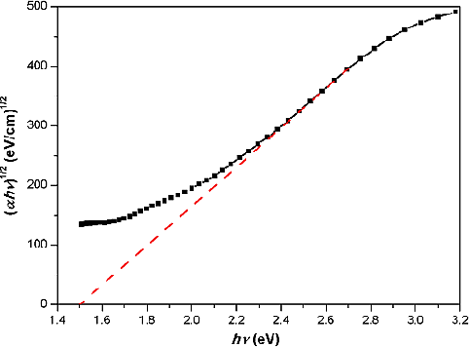

Figure 1.2: This schematic diagram, as described by Yuan et al. (2014)
Figure 1.2 is an example of one of the measurements of the energy gap of amorphous silicon thin films using the Tauc Plot method. Through a linear line drawn to intersect the x-axis, it can be determined that the energy band gap of the film is around 1.5 eV. A decrease in the energy band gap will be accompanied by an increase in the absorption level of the film. Thin films can only absorb photons with higher energy than their energy gap, while photons with lower energy are reflected. Therefore, the energy band gap of the film is an important parameter in the absorption and transmittance aspects that can affect the efficiency of solar cells from the sunlight energy entering the film.
Amorphous silicon is a semiconductor material that is widely studied and used in various thin-film technologies. One of its main applications is in solar panels (photovoltaic or PV). However, the efficiency of solar panels using amorphous silicon is still relatively low. Currently, PV modules based on amorphous silicon with a single-pin structure can only achieve efficiencies of around 6-8%. This One way to make solar cells better is to improve the performance of amorphous silicon (a-Si) solar panels. Amorphous silicon has an energy band gap of around 1.8 eV, which is ideal for absorbing energy from sunlight. The graph shows that the highest efficiency can be achieved with an energy band gap around this value. Theoretically, ideal amorphous silicon solar cells can achieve efficiencies approaching 30%, making it a very promising material for solar cell manufacturing.

External Factors Affecting Band Gap
In addition to intrinsic properties, the band gap can be influenced by:
    - Temperature: The band gap tends to narrow at high temperatures due to expansion of the crystal lattice and increased atomic vibrations.
    - Doping: The addition of foreign atoms can modify the energy levels in the valence and conduction bands (example: n and p doping in semiconductors).
    - Pressure and stress: Can cause changes in crystal structure and affect the bandgap energy.
    - Particle size: In the nanoscale (quantum dot), the band gap can be increased due to the energy quantization effect (quantum confinement).

Band Structure: Direct vs Indirect Band Gap
The fundamental difference between direct and indirect band gap semiconductors lies in the energy band structure and electron transition mechanism.

Direct Band Gap
In direct band gap semiconductors, the minimum position of the conduction band and the maximum of the valence band are in the same momentum (k-space). This means that electrons can move directly from the conduction band to the valence band by emitting photons, without the help of momentum changes. This makes it very efficient in the process of light emission.
Examples: GaAs, GaN, InP.
Indirect Band Gap
In indirect band gap semiconductors, the conduction band minimum and valence band maximum are not at the same momentum. Electron transitions require additional interactions with phonons (lattice vibrations) to change momentum. This process is inefficient in emitting light, making it unsuitable for optoelectronic applications.Example: Si, Ge.
The energy of electron is given by ,
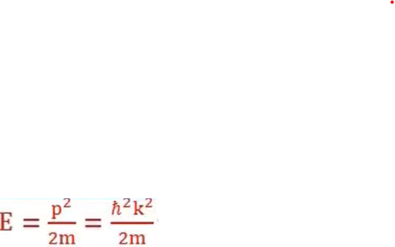
Where, P is momentum , m is mass of electron, h is plank constant and k is propagation constant.
The relation E is directly proportional to k2 is equation of parabola.
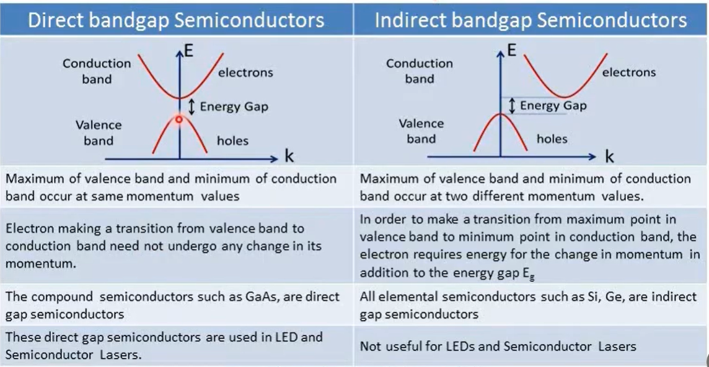

Band Gap Contribution to the Technological Revolution
The development of modern technology is highly dependent on band gap engineering, for example:
- Materials with direct band gap are ideal for LED (Light Emitting Diode), photonic sensors and devices. Here the light emission is recombination of electrons and holes (radiative recombination) by direct band gap material due to strong absorption. eg.,GaN and InGaN based on materials, energy-efficient LEDs and full-color displays
- Materials with indirect gap such as silicon that have an indirect band gap are not used in making LEDs because the light produced is very weak or almost nonexistent. This is why even though silicon dominates the microelectronics industry, it is not used in light-emitting applications.
- A new generation of solar cells that combine direct band gap materials and multi-junction structures to capture a wider spectrum of light.
- Importance of refractive index, optical absorption and band gap in semiconducting materials:
- The refractive index of semiconducting materials is a crucial factor in determining their optical and electronic properties. It is a dimensionless quantity that describes how much light slows down or bends when it enters the material. The refractive index is closely related to the energy gap of the material, which determines the threshold for absorption of photons. A correlation between the refractive index and energy gap is significant for the design and performance of devices such as photonic crystals, wave guides, solar cells, and detectors. The relationship is based on the photo effect studies and the effective dielectric constant of the material.
1. Energy Gap (Eg) and Refractive Index (n) relation
• Refractive index is the ratio of velocity of light in vacuum to that in the material.
• In semiconductors, the refractive index decreases with increase in energy gap.
That can be understood by following Empirical Relations:

(a) Moss Relation
n^4 × Eg = constant

(b) Ravindra Relation
n = 4.084 − 0.62 × Eg

(c) Herve–Vandamme Relation
n^2 = 1 + [13.6 / (Eg + 3.4)]^2
From the above equations, we can say that the refractive index is inversely proportional to the band gap.
Narrow band gap → High refractive index
Wide band gap → Low refractive index

Optical Absorption and in Semiconductors
Optical absorption occurs when photon energy (hν) ≥ energy gap (Eg).
Electrons are excited from valence band to conduction band.
Absorption Coefficient:
I = I0 × e^(−αx)
Where:
I0 = incident light intensity
I = transmitted intensity
α = absorption coefficient
x = thickness of semiconductor
2. Energy Gap and Optical Absorption (Tauc Relations)
(a) Direct Band Gap Semiconductors
(Example: GaAs, InP)
α × hν = A × (hν − Eg)^(1/2)
• Strong absorption
• Sharp absorption edge
(b) Indirect Band Gap Semiconductors
(Example: Si, Ge)
α × hν = A × (hν − Eg)^2
• Weak absorption
• Phonon participation required

4. Relation Between Refractive Index and Absorption
Complex Refractive Index:
ñ = n + i k
Where:
n = refractive index
k = extinction coefficient
Absorption Coefficient:
α = (4 × π × k) / λ
Note:
k tells how strongly electrons absorb light at a given wavelength.
α tells how fast light intensity decays as it travels through the semiconductor.
Optical absorbance is directly proportional to the extinction coefficient 𝑘, which is the imaginary part of the refractive index.
5. Importance of Refractive Index in Semiconducting Materials
- Controls speed and propagation of light in semiconductors.
- Important for LEDs, laser diodes, photodetectors, and solar cells.
- Helps reduce reflection losses using anti-reflection coatings.
- Inversely related to energy gap, useful for estimating Eg.
- Used in optical waveguides and photonic devices.
- Useful for optical characterization of materials.
Refractive index is important because it controls light reflection, transmission, confinement, and absorption in optoelectronic devices.
Note:
• Increase in Eg → Decrease in k → Decrease in Absorbance→ Decrease in n
• Direct band gap → Strong absorption
• Indirect band gap → Weak absorption
• Absorption edge gives value of energy gap

Basic material properties needed for semiconductor device fabrication:
Semiconductor materials are an essential part of almost all current electronic devices, from microprocessors and sensors to light-emitting diodes and solar cells. Their unique ability to conduct electric current under certain conditions makes them ideal for switching, amplification and energy conversion functions.

Key Properties of Semiconductors
1. Band Gap Energy ((Eg))
Smaller Eg gives easier conduction, while larger Eg gives better high-temperature and high-voltage performance.
Small band gap → easier conduction (e.g., Germanium)
Large band gap → higher temperature and voltage tolerance (e.g., SiC, GaN) (GaN: ~3.4 eV, wide band gap, useful for high-power devices)
2. Intrinsic Conductivity:
The natural ability of a pure semiconductor to conduct electricity without impurities. Conductivity is very low in pure materials, but can be controlled by adding dopants.
Intrinsic conductivity is important in semiconductor devices because it determines the natural carrier concentration, temperature behavior, leakage current, breakdown voltage, and overall device stability before doping.

Low intrinsic conductivity at room temperature is required
→ So that conductivity can be controlled effectively by doping.
→ Ensures proper formation of PN junctions.
Should increase with temperature in a controlled way
→ Helps in temperature sensing devices.
→ Excessive intrinsic conduction at high temperature causes leakage current.
Low intrinsic carrier concentration improves device performance
→ Reduces unwanted current in diodes and transistors.
→ Increases breakdown voltage.
Wide band gap materials are preferred for power devices
→ Very low intrinsic conductivity
→ Can operate at high temperature and high voltage
(Example: SiC, GaN)
Provides basic understanding before doping
→ Device design starts from intrinsic properties.
3. Mobility:
Mobility (μ) is the measure of how fast a charge carrier moves per unit electric field.
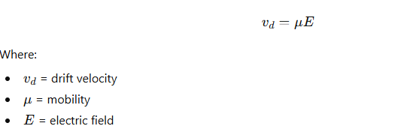
The speed at which charge carriers (electrons and holes) move through the crystal lattice under an electric field.
Higher mobility → faster switching speeds in transistors. Units: cm²/(V·s)
Example: Electrons in GaAs have higher mobility than in silicon, making GaAs useful for high-frequency applications.
4. Thermal Conductivity
Thermal conductivity in semiconductors is crucial for managing heat in electronic devices, influencing their performance and reliability.
Thermal conductivity in semiconductors is crucial for managing heat in electronic devices, influencing their performance and reliability. Thermal conductivity is a measure of a material's ability to conduct heat, represented by the symbol 'k' and expressed in watts per meter-kelvin (W/m·K). In semiconductors, thermal conductivity plays a vital role in determining how effectively heat is dissipated from devices such as transistors, diodes, and integrated circuits. Efficient thermal management is essential to prevent overheating, which can lead to device failure or reduced performance.
Semiconductors generally have moderate thermal conductivity compared to metals and insulators. Here are some typical values for common semiconductor materials at room temperature:
- Silicon (Si): Approximately 149 W/m·K.
- Gallium Arsenide (GaAs): Ranges from 50 to 100 W/m·K, depending on purity and temperature.
- Silicon Carbide (SiC): Can reach up to 490 W/m·K, making it suitable for high-temperature applications.
- Boron Arsenide (BAs): Exhibits exceptionally high thermal conductivity, potentially reaching 1300 W/m·K, which is comparable to some metals.
5. Dielectric Constant
The dielectric constant of a semiconductor indicates its ability to store electrical energy in an electric field. A moderately high dielectric constant is desirable as it improves electric field control and capacitance in semiconductor devices.
The dielectric constant (also called relative permittivity) tells you how well a material can store electric energy when an electric field is applied.
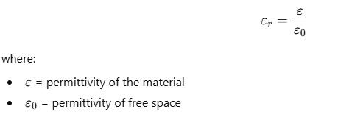
High dielectric constant (high-k) is good for the gate oxide in devices like MOSFET because it: Gives better control of current, Reduces leakage and Improves device performance.
Low dielectric constant (low-k) is good for wires (interconnects) inside chips because it:
Reduces unwanted capacitance, Makes signals travel faster, Saves power
6. Resistivity (ρ)
Resistivity is the opposition to current flow in a semiconductor. Semiconductors require moderate and controllable resistivity, which can be adjusted by doping to allow proper device operation.
It determines current flow, used to classify materials (conductor / semiconductor / insulator) and critical for device design and IC fabrication
7. Breakdown Voltage
The maximum voltage a material can withstand before electrical failure occurs.
Importance: Critical for power electronics; higher breakdown voltage allows devices to handle larger voltages safely.
Example: Wide band gap materials (like SiC, GaN) have much higher breakdown voltages than silicon.
8. Doping Capability
The ability to introduce controlled impurities (dopants) into a semiconductor to modify its conductivity.
Types:
n-type doping: Adds extra electrons (e.g., phosphorus in silicon).
p-type doping: Creates holes by removing electrons (e.g., boron in silicon).
Importance: Enables the creation of diodes, transistors, and integrated circuits.

Semiconductor Fabrication: Understanding Its Processes and Importance
Device Fabrication:
Integrated Circuits (ICs) are the foundation of modern electronic systems and play a vital role in computers, communication devices, medical instruments, and automation technologies. They are manufactured through semiconductor device fabrication processes, where microscopic components such as transistors and diodes are integrated onto a single silicon chip. Continuous advancements in fabrication technology have enabled miniaturization, improved performance, and reduced power consumption, making ICs essential for modern technological development.

Device Fabrication/ Fabrication of Chips And Microprocessors:
The fabrication of a device involves a multi-step procedure for manufacturing and assembling numerous technical components. In semiconductor engineering, this procedure is applied to the production of chips, integrated circuits (ICs), and microprocessors, where carefully controlled physical and chemical processes are used to build highly compact and efficient electronic circuits on silicon wafers
Basic Steps in Chip Fabrication
Fabrication of chips is an incredibly precise process that turns raw silicon into a functional brain for an electronic device Steps for Fabrication of chips:
1. Silicon Wafer Preparation
2. Deposition & Coating
3. Photolithography
4. Etching & Ion Implantation

Q.Explain the steps in chip fabrication.
1. Silicon Wafer Preparation
The process begins with Electronic grade silicon. This silicon is melted and formed into a single large crystal called an ingot. Slicing and Polishing →The ingot is being sliced with a diamond saw into thin circular wafers. Then the wafers are polished to a mirror-like finish to ensure there are no microscopic bumps or scratches.

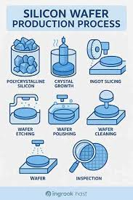
2. Deposition & Coating
To create the different layers of the circuit, different materials must be added to the silicon wafer. • Insulation →A layer of silicon dioxide is grown on the surface using high-temperature oxidation.
• Deposition →Thin films of conducting metals or semiconducting materials are added by Chemical Vapour Deposition (CVD) or Physical Vapour Deposition (PVD).

3. Photolithography
This is the process where the actual circuit design is being transferred onto the wafer.
• Photoresist → The wafer is coated with a light-sensitive liquid called photoresist.
• Exposure → Deep Ultraviolet (DUV) or Extreme Ultraviolet (EUV) light is projected through a mask (a template of the circuit) onto the wafer.
• Development → The wafer is washed in a chemical developer. Depending on the type of photoresist used, the light-exposed areas are either hardened or washed away, leaving a precise pattern behind.
4. Etching & Ion Implantation
Now that the pattern is printed, the physical structure of the chip is carved out.
• Etching: → A dry gas or wet chemical removes the unprotected layers of material, leaving only the pattern defined by photolithography.
• Ion Implantation: → The wafer is bombarded with ions (like Boron or Phosphorus). These ions penetrate the silicon to change its electrical properties, creating the Source and Drain regions of the transistors.
Q. What is Photolithography?
Photolithography is a technique that is used to define the shape of micromachined structures on a wafer.
Photolithography, also termed optical lithography or UV lithography, is a process used in micro-fabrication to pattern parts of a thin film or the bulk of a substrate. It uses light to transfer a geometric pattern from a photomask to a light-sensitive chemical "photoresist", or simply "resist," on the substrate. A series of chemical treatments then either engraves the exposure pattern into, or enables deposition of a new material in the desired pattern upon, the material underneath the photo resist. For example, in complex integrated circuits, a modern CMOS wafer will go through the photolithographic cycle up to 50 times.
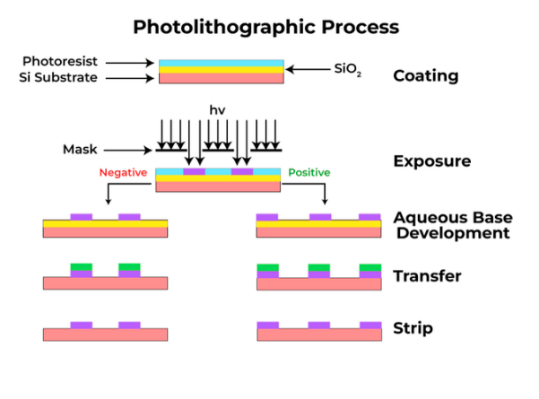
Processing Steps in Photo-Lithography:
- Dehydration: Removes the water molecules from the substrate surface, makes the surface hydrophobic, which increase the adhesion between substrate and photo-resist
- Priming: In this step, an adhesion promoter known as primer is added to the substrate surface.
- Application of photo-resist: Photo-resist is applied to substrate surface through either spin coating or spray coating
- Soft Bake / Pre-bake: Excess solvent in photo-resist is driven out of the film by heat
- Pattern Alignment: Pattern of mask is aligned with the pattern on substrate
- Post-exposure Bake: In this step, the photo-resist is further cross-linked by heating Photo-resist Exposure: Photo-resist undergoes cross-linking under the illumination of UV light. Photo-resist Development: Exposed positive resist or unexposed negative resist is dissolved in developer leaving needed part on substrate surface.
- Hard Bake: Photo-resist is further baked to remove pin-holes and make it denser to facilitate the later etching step.
- Phot-Resist Removal: Photo-resist is removed by chemicals that can either dissolve or oxidize photo-resist.
Q. Write a short note on photoresist used in photolithography.”/“Explain photoresist and its role in semiconductor fabrication.”
Photoresist is a light-sensitive polymer material used in photolithography to transfer circuit patterns onto a silicon wafer during semiconductor fabrication. It acts as a temporary protective layer that defines specific regions for etching or doping.
Composition of Photoresist
A typical photoresist consists of:
Polymer (Resin): Forms the structural base.
Photoactive Compound (PAC): Reacts chemically when exposed to light.
Solvent: Keeps the resist in liquid form for spin coating.
Additives: Improve adhesion and stability.
Requirement of Photoresist
High resolution
-Thinner PR film has higher the resolution
-Thinner PR film, the lower the etching and ion implantation resistance
High etch resistance
Good adhesion
-Wider process latitude Higher tolerance to process conditions like spin rate, baking temperature and exposure flux
Working Principle
- The wafer is coated with liquid photoresist.
- It is exposed to ultraviolet (UV) light through a mask.
- Light causes a chemical change in the exposed regions.
- A developer solution removes either the exposed or unexposed regions.
- A patterned resist layer remains on the wafer.
- This patterned layer protects selected areas during etching or ion implantation.

Positive and Negative Photoresist
There are two types of photoresist: positive and negative.
For positive resists, the resist is exposed with UV light wherever the underlying material is to be removed. In these resists, exposure to the UV light changes the chemical structure of the resist so that it becomes more soluble in the developer. The exposed resist is then washed away by the developer solution, leaving windows of the bare underlying material. In other words, "whatever shows, goes." The mask, therefore, contains an exact copy of the pattern which is to remain on the wafer.
Negative resists behave in just the opposite manner. Exposure to the UV light causes the negative resist to become polymerized, and more difficult to dissolve. Therefore, the negative resist remains on the surface wherever it is exposed, and the developer solution removes only the unexposed portions. Masks used for negative photoresists, therefore, contain the inverse (or photographic "negative") of the pattern to be transferred. The figure below shows the pattern differences generated from the use of positive and negative resist.
Q. Comment on deposition techniques -
- PVD
- CVD
- AVD
Physical Vapor Deposition (PVD)
Physical Vapor Deposition (PVD) is a widely used thin film deposition technique in the manufacturing of devices. PVD involves the physical ejection of material from a source (target) and its subsequent deposition onto a substrate, typically under vacuum conditions.
- Sputtering Deposition
Sputtering deposition is a PVD method commonly employed in the optoelectronics industry. In this process, a target material is bombarded with high-energy particles, typically ions, causing the target atoms to be ejected and deposited onto the substrate. Sputtering deposition allows for the deposition of a wide range of materials, including metals, alloys, and ceramics, making it a versatile technique for the fabrication of optoelectronic devices.
- Evaporation Deposition
Evaporation deposition is another PVD technique used in the manufacturing of electronic devices. In this process, the source material is heated, typically using an electron beam or resistance heating, causing it to evaporate and condense onto the substrate. Evaporation deposition is particularly well-suited for the deposition of high-purity thin films, as it allows for excellent control over the deposition rate and film thickness.
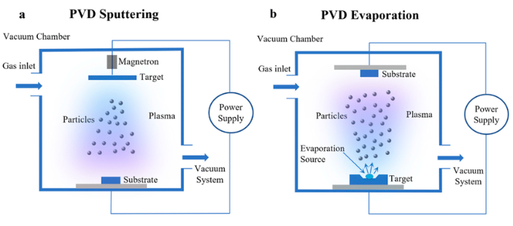
FIGURE: PVD deposition coating methods: (a) sputtering, (b) evaporation.

Chemical Vapor Deposition (CVD)
Chemical Vapor Deposition (CVD) is another thin film deposition technique that is widely used in the manufacturing of electronic devices. In CVD, a substrate is exposed to one or more volatile precursor chemicals, which react and/or decompose on the substrate surface to produce the desired thin film material. This process allows for the precise control of film composition, thickness, and uniformity, making it a crucial tool in the fabrication of high-performance optoelectronic components.
CVD working principle:
Chemical vapor deposition processes can be defined as any process in which a thin solid film is formed on a substrate by the surface-mediated reaction of adsorbed precursors from the gas phase. The reactive nature of CVD processes distinguishes them from physical processes such as evaporation and sputtering that are employed in PVD. The term "surface-mediated" refers to the fact that the solid film is formed by a heterogeneous reaction occurring at the substrate surface.
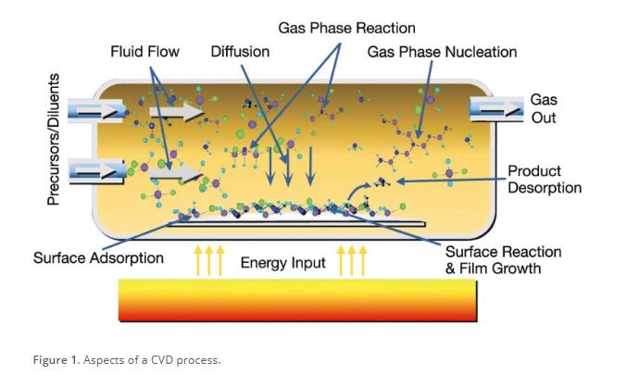
Figure: Aspects of CVD
Above Figure shows a schematic that can help in understanding the different processes in a CVD reactor. Chemical vapor deposition processes can be broken down into a number of discrete steps:
First the precursor chemicals must be fed into the CVD reactor. Once in the reactor, precursor molecules must be transported to the substrate surface, usually through a combination of fluid transport and diffusion. Once on the surface, the precursor molecule must remain there long enough to react. After reaction occurs, the product thin film atom must remain on the surface while the by-product molecules must desorb from the substrate surface to make room for more incoming precursor molecules.

Low-Pressure CVD
Low-Pressure CVD (LPCVD) is a variant of the CVD process that operates under reduced pressure conditions. By lowering the pressure, LPCVD can improve the quality and uniformity of the deposited thin films, as well as increase the deposition rate. This technique is commonly used for the deposition of polycrystalline silicon, silicon nitride, and other materials critical to the production of optoelectronic devices.

Plasma-Enhanced CVD
Note: Plasma is the fourth state of matter—distinct from solid, liquid, or gas—consisting of highly ionized gas with free-moving electrons and ions.
Plasma-Enhanced CVD (PECVD) is another important CVD technique that utilizes a plasma to activate and decompose the precursor gases. The plasma provides the necessary energy to facilitate the chemical reactions at lower substrate temperatures, making it a versatile option for depositing thin films on temperature-sensitive materials. PECVD is widely used in the production of amorphous silicon, silicon nitride, and other thin film coatings for optoelectronic applications.
‍Importance
- Chemical Vapor Deposition (CVD) for devices is a manufacturing process that deposits high-purity, high-performance solid materials onto a substrate (wafer) by triggering chemical reactions in a vapor phase. It is essential for creating thin films in semiconductors, MEMS, and electronics, specifically depositing dielectric layers, metals, and carbon nanostructures
- Typical films produced by CVD processes include:
(Note: Epitaxy is a, fabrication process used in, semiconductor manufacturing to grow a thin, single-crystal film on a crystalline substrate, ensuring the new layer matches the crystal orientation of the underlying material. It enables precise, high-purity, and defect-free material, crucial for advanced microchips, solar cells, and LED devices. )
- Epitaxial Silicon (Epitaxial silicon (EPI) is a high-purity, monocrystalline silicon layer grown on a polished silicon substrate, typically via chemical vapor deposition (CVD) at temperatures around 1100°C)
- Epitaxial Compound Semiconductors
- Polycrystalline Silicon
- Dielectric Thin Films
  - Silicon Dioxide (including P- and B-doped Oxides)
  - Aluminum Oxide
  - Low-k Dielectrics (SiO-F, DLC, amorphous C-F) (Low-k dielectrics are insulating materials with a low dielectric constant, k < 3.9 the value for silicon dioxide) used in semiconductor manufacturing to separate electrical interconnects, reducing signal crosstalk and latency while lowering heat dissipation)
  - Silicon Nitride
  - Titanium Nitride
  - Tantalum Nitride
  - Transition Metal Oxides (i.e. TiO2, ZrO2, Hf2O5, Ta2O5)
- Metals (Al, W, Cu)
- Silicides (WSix, CoSix)

Atomic Layer Deposition (ALD)
In the world of thin film deposition, Atomic Layer Deposition (ALD) has emerged as a groundbreaking technique that is revolutionizing the manufacturing of optoelectronic devices. Unlike traditional thin film deposition methods, ALD is a self-limiting, sequential process that involves the exposure of a substrate to alternating precursor gases, which react to form a single atomic layer of the desired material.
The precision and control offered by ALD make it an invaluable tool for nanoscale engineering, where the ability to precisely control the thickness and composition of thin films is crucial. This precise control, combined with the ability to deposit high-quality, conformal films on complex surfaces, has made ALD a go-to choice for the fabrication of cutting-edge optoelectronic devices, ranging from solar cells to semiconductor lasers.
As the demand for ever-smaller and more efficient optoelectronic devices continues to grow, the role of ALD in the manufacturing process has become increasingly important. By enabling the deposition of ultra-thin, high-quality films with exceptional uniformity and conformality, ALD has become a key enabler of the ongoing advancements in the optoelectronics industry, paving the way for the development of innovative new technologies that push the boundaries of what is possible.
Working Principles:
Atomic layer deposition is similar to LPCVD except that the chemical process is broken down into steps that isolate different adsorption and reaction steps to have self-limiting reactions. The process employs separate pulses of precursors and reactants that pass sequentially through the process chamber. Figure 1 illustrates the ALD process. With the substrate in the process chamber and under high vacuum, an initial precursor is introduced into the chamber. The molecular character of the precursor is such that it will form a chemically-bound monolayer on the substrate surface (Step 1). Any layers beyond the monolayer are only bound by physisorption forces which are weak enough to allow any precursor other than that in the monolayer to be pumped away under high vacuum. Once the monolayer is present on the substrate, the chamber is re-evacuated and purged to remove any excess precursor (Step 2). Next, a reactant is introduced to the process chamber (Step 3). It reacts with the monolayer material to form the desired compound on the substrate surface (Step 4). By-products of this reaction are pumped away.
